Exercises: HTTP Protocol
Problems for exercises and homework for the “Java Web Development Basics” course @ SoftUni. Submit your solutions on the course page of the current instance.

Parsing HTTP Requests
Implement a simple java application which parses HTTP Requests and returns an appropriate response based on the Request.
You will receive an input of several lines. The first input line will contain several URL paths, separated by spaces.
Example: /path /register /login /products/create /admin/users/all
You should store these paths, they are the valid URLs.
The next several input lines will contain information about a simple HTTP Request.
Example:
POST /url HTTP/1.1
Date: 17/01/2019
Host: localhost:8000
Content-Type: application/xml
Authorization: Basic UGVzaG8=
name=Yum&quantity=50&price=10
You must implement a simple parser, which parses specific information, from the given request data, and returns a well-formatted HTTP Response in text format.
You must process the Request Line.
- Check if the URL is present in the valid URLs
You may be given any header, but you must only process the Date, Host, Content-Type headers.
- Attach the headers to the HTTP Response’s headers
- If any of the headers is missing you don’t need to do anything.
- Skip the Authorization header for this
You must also process the Request Body.
- Split the body parameters
In the end you should return a Response which contains the processed data from the request in an aggregated format.
HTTP/1.1 200 OK
Date: 17/01/2019
Host: localhost:8000
Content-Type: application/xml
Greetings Pesho! You have successfully created Yum with quantity – 50, price – 10.

As you can see the Response’s Headers are the same as the Request’s Headers. The Response Body is the only new thing. It is created in the following format.
Greetings {username}! You have successfully created {firstRequestBodyParameterValue} with {secondRequestBodyParameterName} – {secondRequestBodyParameterValue}, {thirdRequestBodyParameterName} – {thirdRequestBodyParameterValue}.
The username is extracted by decoding with Binary64Decoder the Authorization Header’s value (after the Basic credential key).
Example: Authorization: Basic UGVzaG8= -> Pesho
Then you must format the Request’s body parameters and place them in the Response content.
NOTE: If the URL is invalid (not present in valid URLs given on the first line), you should return an HTTP Response in the same format but this time with:
- Status - 404 Not Found
- Response Body – "The requested functionality was not found."
NOTE: If the Authorization header is missing, you should return an HTTP Response in the same format, but with:
- Status - 401 Unauthorized
- Response Body – "You are not authorized to access the requested functionality."
NOTE: If the Request’s Method is POST and there is NO body parameters, you should return an HTTP Response in the same format but with:
- Status – 400 Unauthorized
- Response Body – "There was an error with the requested functionality due to malformed request."
If the Request’s Method is GET just print "Greetings {username}!" as Response body.

Example
Input | Output
/url /login /register  POST /url HTTP/1.1  Date: 17/01/2019  Host: localhost:8000  Content-Type: application/xml  Authorization: Basic UGVzaG8=  name=Yum&quantity=50&price=10 | HTTP/1.1 200 OK  Date: 17/01/2019  Host: localhost:8000  Content-Type: application/xml  Greetings Pesho! You have successfully created Yum with quantity – 50, price – 10.
/url /login /register  POST /url HTTP/1.1  Date: 17/01/2019  Host: localhost:8000  name=Yum&quantity=50&price=10 | HTTP/1.1 401 Unauthorized  Date: 17/01/2019  Host: localhost:8000  You are not authorized to access the requested functionality.
/create /update  POST /url HTTP/1.1  Host: localhost:8000  Authorization: Basic UGVzaG8=  name=Yum&quantity=50&price=10 | HTTP/1.1 404 Not Found  Date: 17/01/2019  Host: localhost:8000  The requested functionality was not found.
/url /update  POST /url HTTP/1.1  Host: localhost:8000  Authorization: Basic UGVzaG8= | HTTP/1.1 400 Bad Request  Date: 17/01/2019  Host: localhost:8000  There was an error with the requested functionality due to malformed request.

Create classes
Now, all the parsing logic from the previous task should be aggregated into 2 classes.
The HttpRequest:
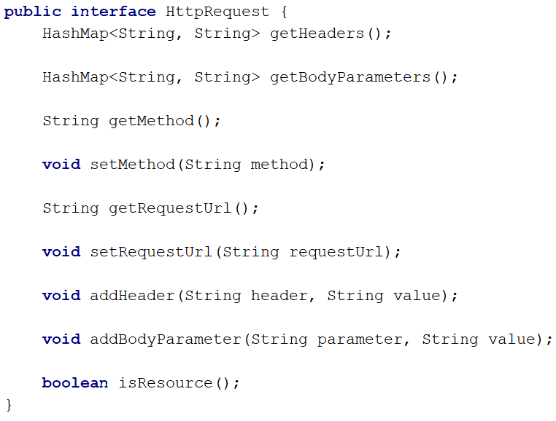
Create a class which implements this interface, and write the logic behind the methods. The class should have a method, a requestUrl, a collection of headers and a collection of bodyParameters.
Remember, a request looks like this:
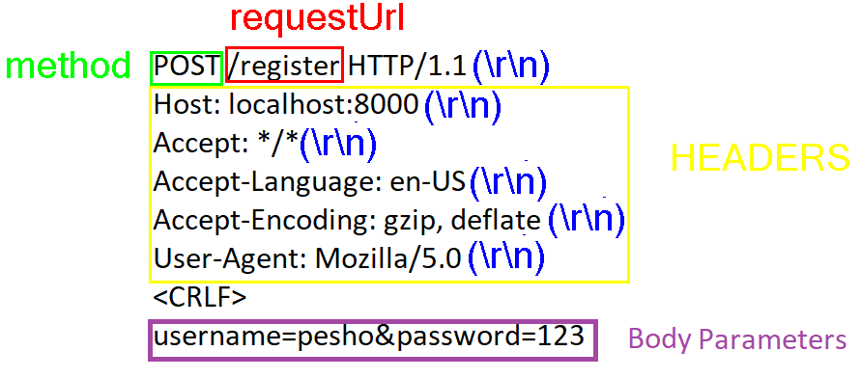
You should receive the string in the constructor of the Request class, exactly as shown above, with every line, delimitered by “\r\n”. Everything should be parsed and formatted INSIDE the class.
The isResource() method should check if the
is a resource and not an actual route, and should return a boolean result.

HttpResponse
And the HttpResponse:
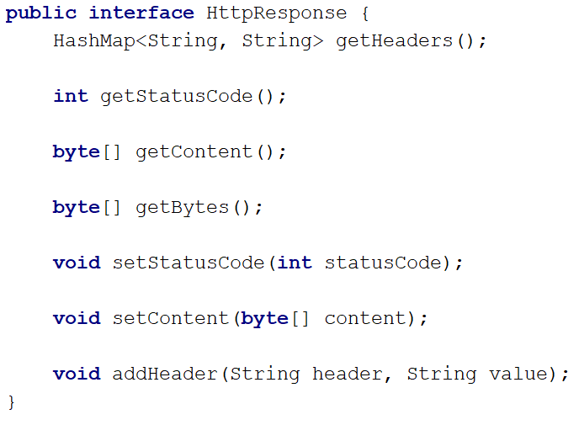
Same as the HttpRequest above, you should implement this class, so that it corresponds to the behaviour defined by the interface.
The getBytes() method should return the whole response (ResponseLine + Headers + Content) as byte array.

